HOSPITAL EMERGENCY ROOM DASHBOARD

-- Number of Patients:
select count(*) as No_of_Patients from hospital_er;

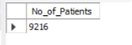

-- Average Wait Time
select round(avg(`patient waittime`),2) as Avg_Wait_Time from hospital_er;

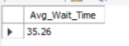
-- Patient Satisfaction Score:
Select AVG(Patient_Satisfaction_Score) as Avg_Satisfaction_Score from [Hospital_ER_Data]

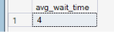

-----4 Number of Patients Referred:
Select count(patient_id) as no_of_patients from [Hospital_ER_data] Hr JOIN Departments D
on Hr.DepartmentID = D.DepartmentID
Where Department_Referral <> 'none'
and
year(Patient_Admission_Date) = 2023
and
Month(Patient_Admission_Date) = 4
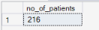

--- Patient Admission Status: Track admitted vs. non-admitted patients.

Select
Case
When patient_admission_flag = 'True' Then 'Admited'
else 'Not_Admited'
End as Admission_Status ,
COUNT(PATIENT_ID) AS No_of_Patients
fROM [Hospital ER_Data]
where YEAR(Patient_Admission_Date) = 2023
and
month(Patient_Admission_Date) = 4
Group By
Case
When patient_admission_flag = 'True' Then 'Admited'
else 'Not_Admited'
End
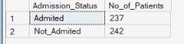

--- Department Referrals: Analyze referral trends across different departments.

Select Department_Referral , count(patient_id) as No_of_Patients
from [Hospital ER_Data] Hr Join Departments D
on Hr.DepartmentID = D.DepartmentID
where year(patient_admission_date) = 2023 and MONTH(patient_admission_date) = 4
group by Department_Referral
order by No_of_Patients Desc
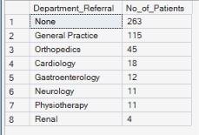

---- weekname wise no of patients

Select DATENAME(weekday,Patient_Admission_Date) as Weekname,
datepart(hour,(Patient_Admission_Date)) as hourrange ,
cOUNT(Patient_id) as no_of_patients from [Hospital ER_Data]
where YEAR(Patient_Admission_Date) = 2023 and MONTH(Patient_Admission_Date)=4
group by DATENAME(weekday,Patient_Admission_Date),datepart(hour,(Patient_Admission_Date))
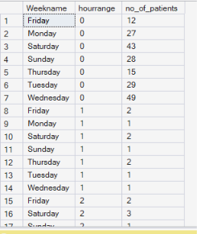

BUSINESS REQUIREMENTS

Dashboard 1: Monthly View

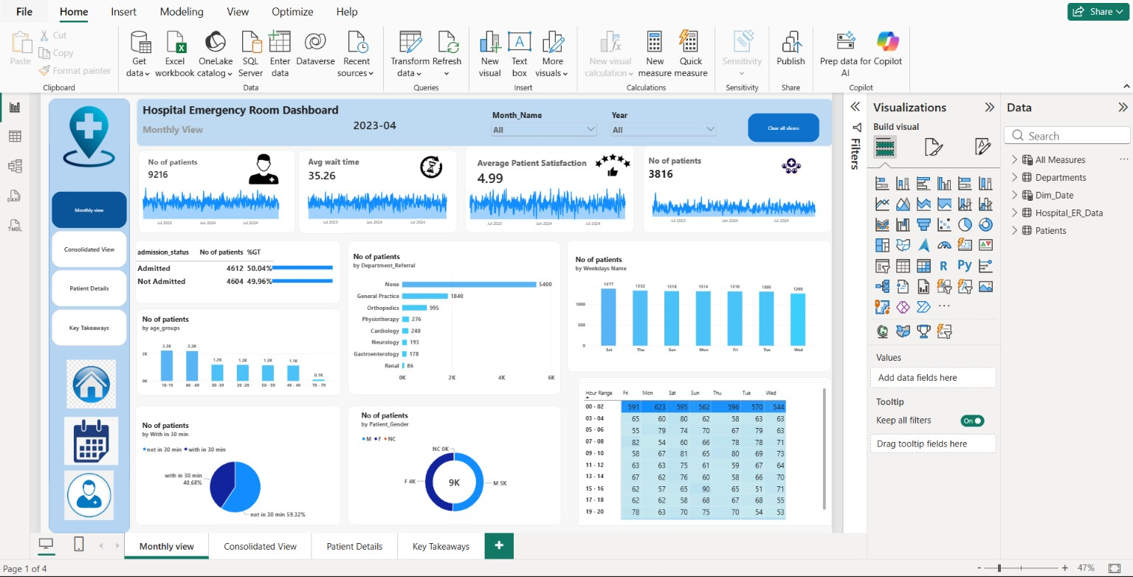
Dashboard 2: Consolidated View

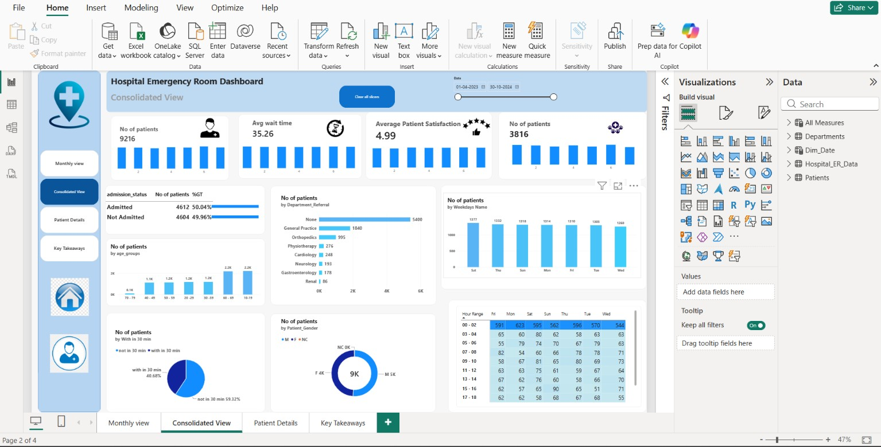

Dashboard 3: Patient Details

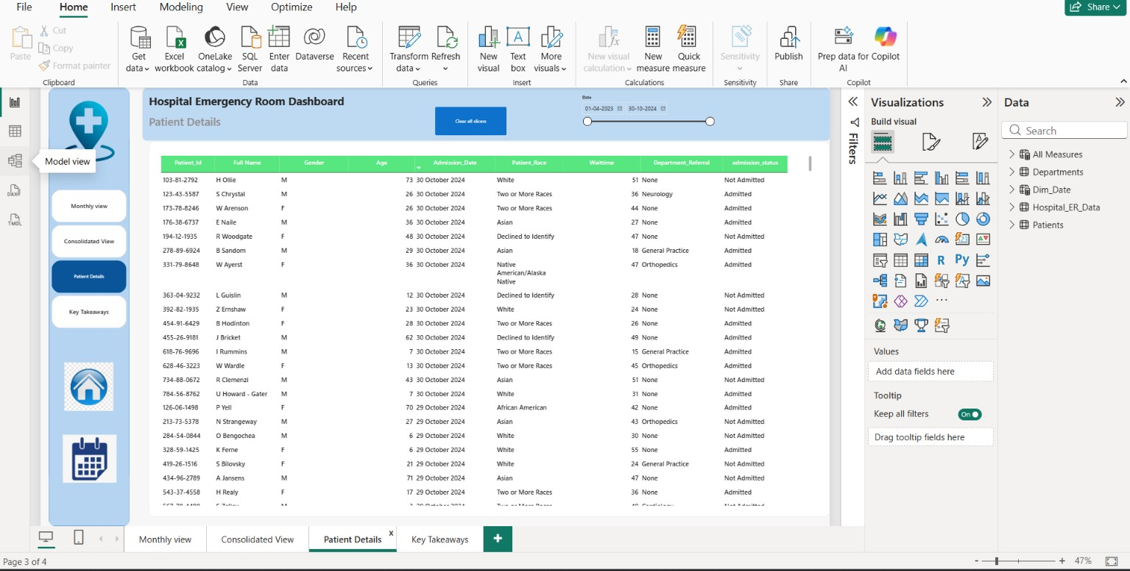

Dashboard 4: Key Takeaways
